NORFOLK COUNTY COUNCIL has made a Temporary Traffic Order affecting Station Road 20m south of its junction with Yareview Close for 40m southwards in the PARISH OF REEDHAM because of works to allow for the installation of core fibre network including excavations.

The road will be temporarily closed (except for access) from 9th to 11th August 2021 for the duration of the works expected to be about 3 days within the period.

Alternative route is via: Station Road, The Hills, Mill Road, Church Road, Pottles Lane, Freethorpe Road.

(If necessary the restriction could run for a maximum period of 18 months from the date of the Order).

Penalty: £1000 maximum fine on conviction and/or endorsement for contravention.

In the event of the start date being delayed the new start date will be displayed on site in advance.

The person dealing with enquiries at Norfolk County Council is Vinnie Purdy (Community and Environmental Services) Telephone 0344 800 8020.

Dated this 6th day of August 2021

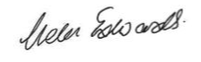

Helen Edwards
Chief Legal Officer

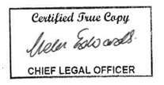

County Hall
Martineau Lane
Norwich
NR1 2DH



